Alaska Indoor Gardening Curriculum

Introduction To Hydroponic Systems
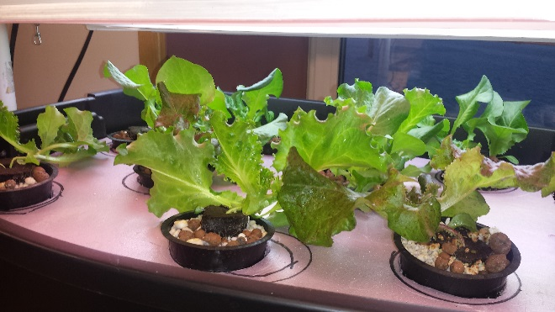
Author/Source: Mel Sikes, Alaska Ag in the Classroom

Suggested Grade Levels: 4th -12th grade

Time: 45 minutes – 1 hour

Teaching Goal:
To introduce students to Hydroponics, the different types of systems, and what components are needed to construct a functioning system

Learning Objectives:
- Using the Introduction to Hydroponics power point, introduce students to the basics of Hydroponic Systems.
- To have students explore the different types of grow mediums and grow lights used in the systems.

Core Topics:
- Introduction to Hydroponic Systems
- Plant Dynamics (circulation and nutrient uptake)
- pH, Acidity, and Alkalinity Testing
- Drawing Conclusions from Lecture and Examples

Alaska Standards: Science: 4-LS1-1, 4-PS3-4, 5-PS3-1, 5-LS1-1, 5-LS2-1, MS-LS2-1, MS-LS2-4, MS-LS2-5, MS-ESS3-3, HS-LS1-2, HS-LS2-5

NGSS Standards: 4-LS1-1, 5-PS3-1, 5-LS1-1, 3-5-ETS1-1, MS-LS1-5, MS-LS2-1, MS-LS3-3, MS-ESS3-3, HS-LS2-7, HS-ESS2-6, HS-ESS3-4, HS-ETS1-1

Materials:
- Powerpoint Presentation on types of hydroponics systems or printed powerpoint slides
- Computer and projector
- Examples of different parts of the hydroponic systems including growing mediums, floating platform, net pots, lights, seed packages, fish tank pump, and tubing.
- Colored Pencils
- Pencils
- Blank Sheets of Paper

Vocabulary:
- Hydroponics: is a method of growing plants in water without soil. The water must be enriched with nutrients and the plants need some type of inert medium to support the root system.

- Medium: substance or material in which something exists or grows, from the soils and other materials for plant growth.

- pH: stands for potential of hydrogen, which is a measurement of the hydrogen ion concentration in the water. Plants grow best in a slightly acidic pH range of 6 to 7.

- Acidity: the level of acid in substances such as water, or soil

- Alkalinity: the ability of water to neutralize acid or to absorb hydrogen ions.

- Algae: algae is an informal term for a large diverse group of photosynthetic organisms which are not necessarily closely related

- Roots: are a very important part of the plant, a roots four major functions are: absorption of water and inorganic nutrients, anchoring the plant, storage of food and nutrients and vegetative reproduction

- Oxygen: plants take in oxygen and give off carbon dioxide nutrients

- Nutrients: plants must obtain the following mineral nutrients for their growing medium they need nitrogen, phosphorus, potassium, calcium, sulfur, and magnesium

Background for Teachers: (info from www.simplyhydro.com/system.htm)

There are 6 basic types of hydroponic systems; Wick, Water Culture, Ebb and Flow (Flood & Drain), Drip (recovery or non-recovery), N.F.T. (Nutrient Film Technique) and Aeroponic. There are hundreds of variations on these basic types of systems, but all hydroponic methods are a variation (or combination) of these six.

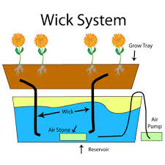
Wick System
The Wick system is by far the simplest type of hydroponic system. This is a passive system, which means there are no moving parts. The nutrient solution is drawn into the growing medium from the reservoir with a wick.
This system can use a variety of growing medium. Perlite, Vermiculite, Pro-Mix and Coconut Fiber are among the most popular.
The biggest drawback of this system is that plants that are large or use large amounts of water may use up the nutrient solution faster than the wick(s) can supply it.

Water Culture
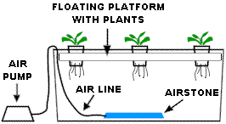
The water culture system is the simplest of all active hydroponic systems. The platform that holds the plants is usually made of styrofoam and floats directly on the nutrient solution. An air pump supplies air to the air stone that bubbles the nutrient solution and supplies oxygen to the roots of the plants.
Water culture is the system of choice for growing leaf lettuce, which are fast growing water loving plants, making them an ideal choice for this type of hydroponic system. Very few plants other than lettuce will do well in this type of system.

This type of hydroponic system is great for the classroom and is popular with teachers. A very inexpensive system can be made out of an old aquarium or other water tight container. The biggest drawback of this kind of system is that it doesn't work well with large plants or with long-term plants.

Ebb and Flow (Flood and Drain)
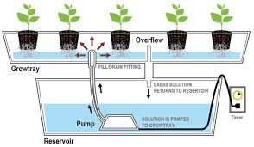
The Ebb and Flow system works by temporarily flooding the grow tray with nutrient solution and then draining the solution back into the reservoir. This action is normally done with a submerged pump that is connected to a timer.
When the timer turns the pump on nutrient solution is pumped into the grow tray. When the timer shuts the pump off the nutrient solution flows back into the reservoir. The Timer is set to come on several times a day, depending on the size and type of plants, temperature and humidity and the type of growing medium used.
The Ebb & Flow is a versatile system that can be used with a variety of growing mediums. The entire grow tray can be filled with Grow Rocks, gravel or granular Rockwool. Many people like to use individual pots filled with growing medium, this makes it easier to move plants around or even move them in or out of the system. The main disadvantage of this type of system is that with some types of growing medium (Gravel, Growrocks, Perlite), there is a vulnerability to power outages as well as pump and timer failures. The roots can dry out quickly when the watering cycles are interrupted. This problem can be relieved somewhat by using growing media that retains more water (Rockwool, Vermiculite, or coconut fiber).

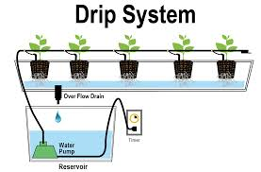
Continuous Drip Systems (Recovery/Non-Recovery)
Drip systems are probably the most widely used type of hydroponic system in the world. Operation is simple, a timer controls a submersed pump. The timer turns the pump on and nutrient solution is dripped onto the base of each plant by a small drip line. In a Recovery Drip System the excess nutrient solution that runs off is collected back in the reservoir for re-use. The Non-Recovery System does not collect the run off.
A recovery system uses nutrient solution a bit more efficiently, as excess solution is reused. The non-recovery system needs to have a more precise timer so that watering cycles can be adjusted to insure that the plants get enough nutrient solution and the runoff is kept to a minimum.
The non-recovery system requires less maintenance due to the fact that the excess nutrient solution isn't recycled back into the reservoir, so the nutrient strength and pH of the reservoir will not vary. This means that you can fill the reservoir with pH adjusted nutrient solution and then forget it until you need to mix more. A recovery system can have large shifts in the pH and nutrient strength levels that require periodic checking and adjusting.

N.F.T. (Nutrient Film Technique)
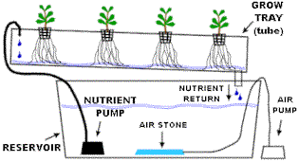
This is the kind of hydroponic system most people think of when they think about hydroponics. N.F.T. systems have a constant flow of nutrient solution so no timer required for the submersible pump. The nutrient solution is pumped into the growing tray (usually a tube) and flows over the roots of the plants, and then drains back into the reservoir.
There is usually no growing medium used other than air, which saves the expense of replacing the growing medium after every crop. Normally the plant is supported in a small plastic basket with the roots dangling into the nutrient solution.
N.F.T. systems are very susceptible to power outages and pump failures. The roots dry out very rapidly when the flow of nutrient solution is interrupted.
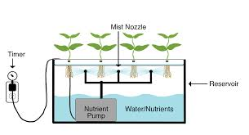
Aeroponic Systems
The aeroponic system is probably the most high-tech type of hydroponic gardening. Like the N.F.T. system above the growing medium is primarily air. The roots hang in the air and are misted with nutrient solution. The mistings are usually done every few minutes. Because the roots are exposed to the air like the N.F.T. system, the roots will dry out rapidly if the misting cycles are interrupted.
A timer controls the nutrient pump much like other types of hydroponic systems, except the aeroponic system needs a short cycle timer that runs the pump for a few seconds every couple of minutes

Procedure:
- Begin the class by asking the students what they know about hydroponics and hydroponic gardening. If your students are struggling, considering writing the word on the board. Ask them what the prefix “hydro” might mean. Ask them to guess and see if you can guide them towards discovering that hydroponics refers to gardening using water.

- Show Power Point presentation or use printouts to give overview of hydroponics.

- Give the students a blank sheet of paper and have them draw their own ideal hydroponic system. Have them pick out the type of system, medium(s) and plants they would like to grow in them and have them draw those out. Have students share ideal set-ups if time.

Extensions: Hydroponic Medium Lesson, Hydroponic Plant Growth Lesson, AITC Plant Nutrition Lessons

Assessment: Review and list all the benefits and disadvantages of each system with students. Consider assessing the student plans that they have come up with for the needed components of the system they chose.

References:
Books
Gardening Indoors with Soil and Hydroponics
by George Van Patten 2007 ISBN: 978-1-878823-32-8

How to Hydroponics by Kenneth Roberto
ISBN: 0-9672026-1-2 2014

Hydroponic Basics: The Basics of Soilless Gardening Indoors
by George F. Van Patton 2004 ISBN: 978-1-878823-25-0

Hydroponics: A Complete DIY Guide for Gardening Using Simple Steps
by Allen Dunn 2012 ISBN: 9781480236141

Websites:
Foothill Hydroponics: http://www.foothillhydroponics.com/
General Hydroponics: http://generalhydroponics.com/
Hydroponics: https://hydroponics.com/
Institute of Simplified Hydroponics: http://carbon.org/
Simply Hydroponics and Organics: http://www.simplyhydro.com/system.htm
Uponics: http://uponics.com/hydroponic-tower/

Wick System

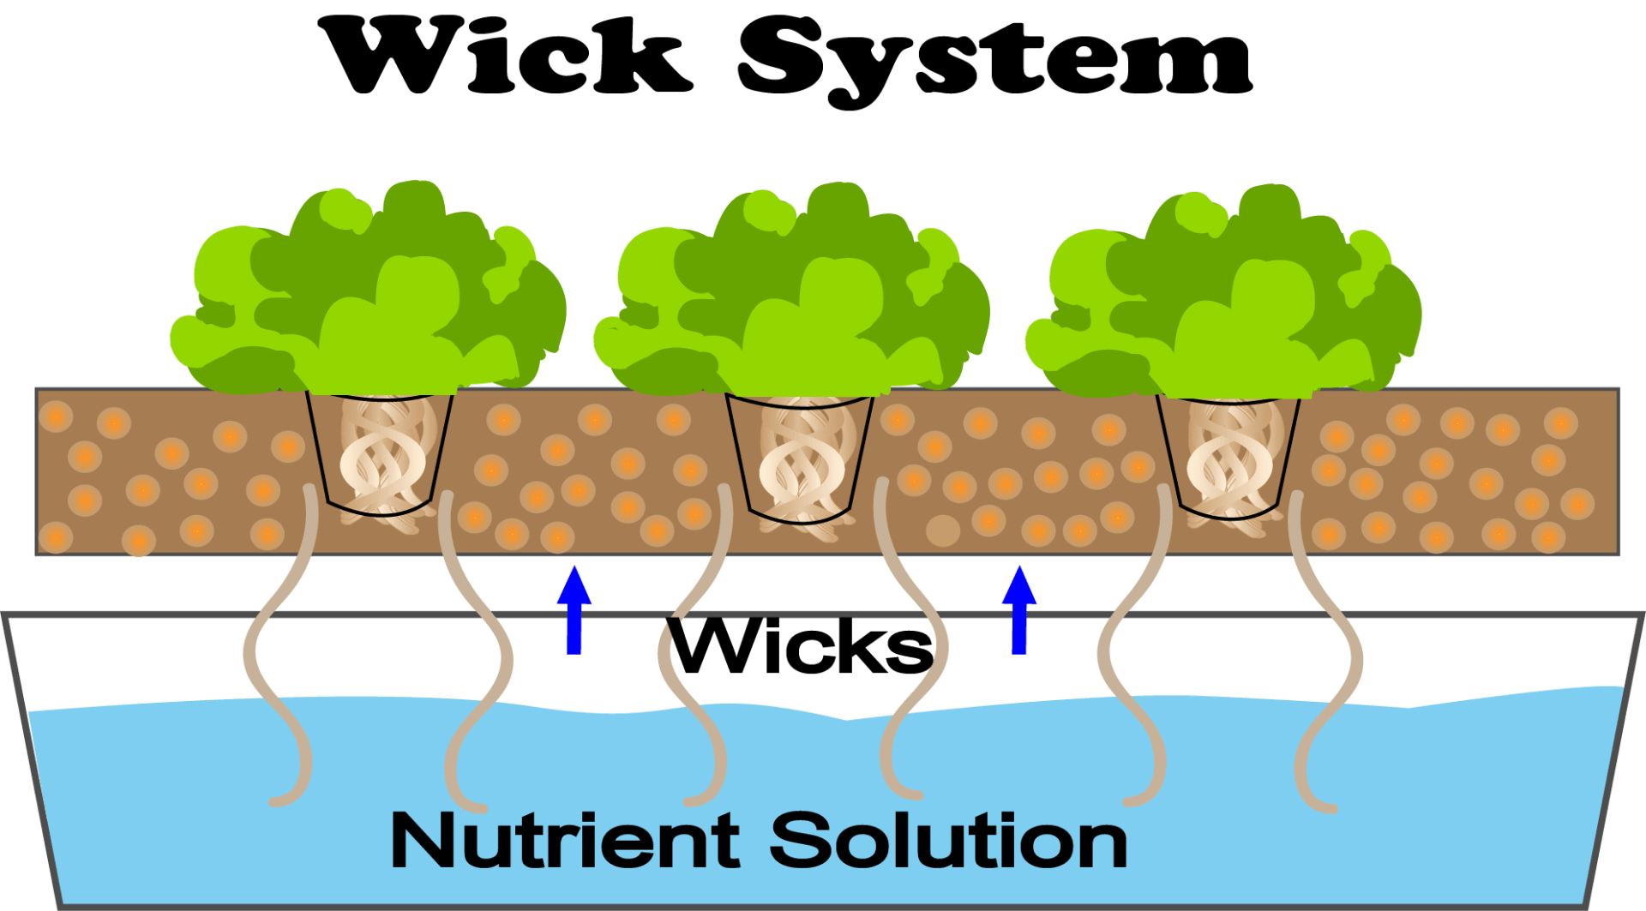

Water Culture (floating platform) System

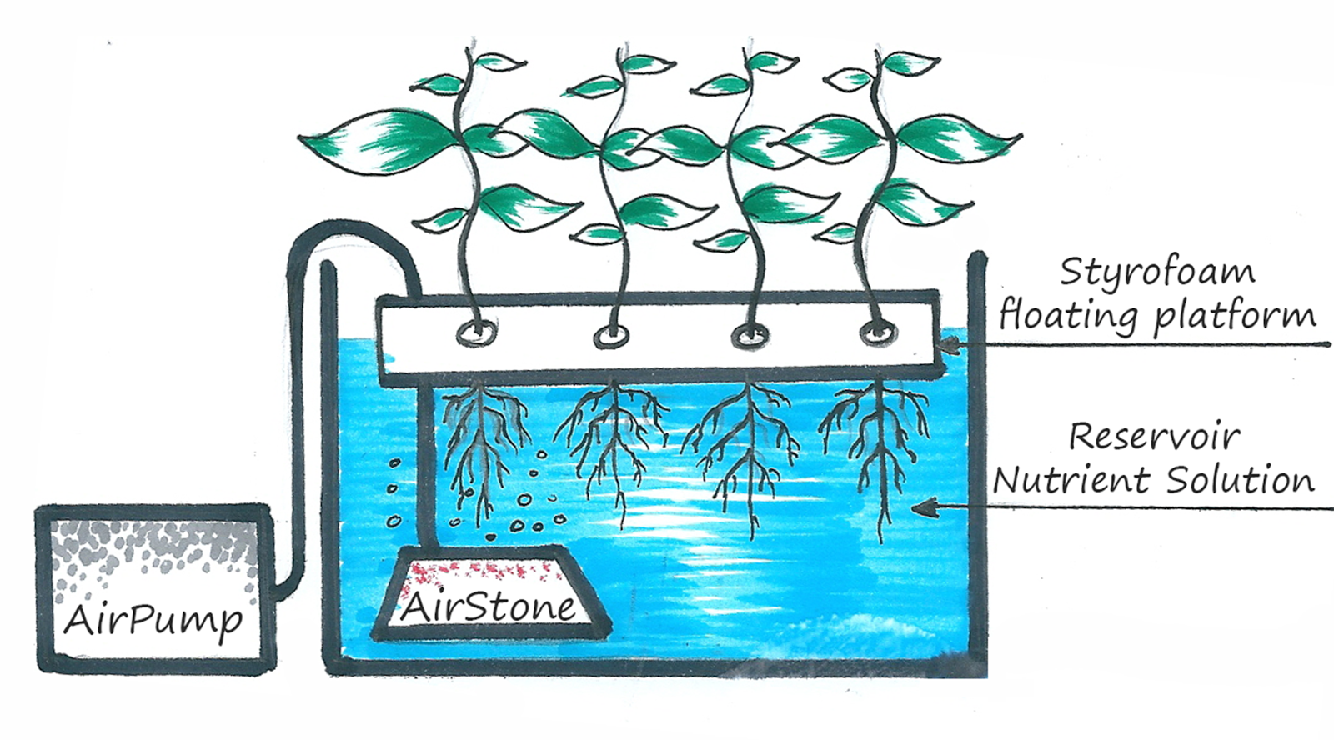

Ebb and Flow (flood and drain) System

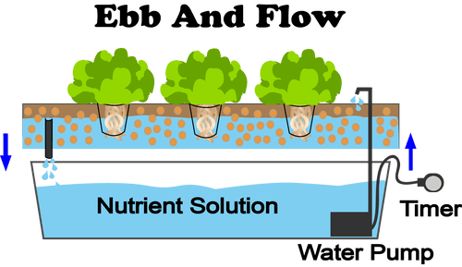

Continuous Drip Systems (Recovery/Non-Recovery)

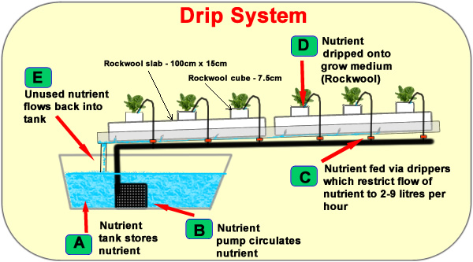

NFT (Nutrient Film Technique) System

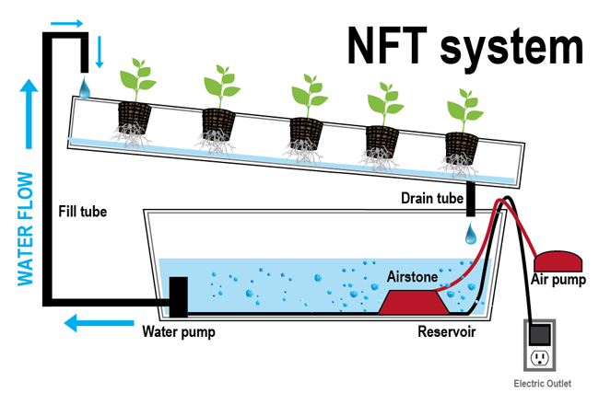

Aeroponic System

